**Outlook Signature Instructions**

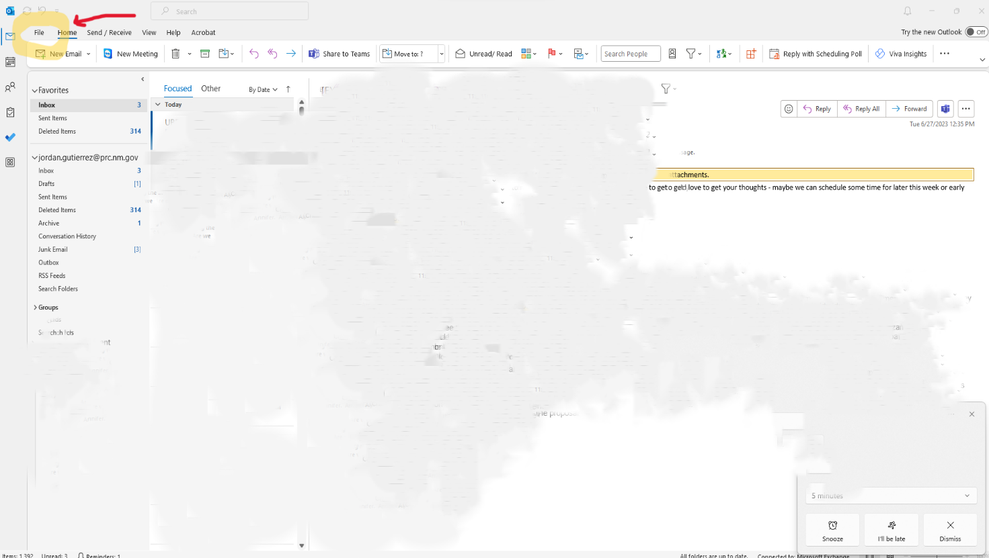**Step 1:** Open your Outlook app and click on the “***File***” tab.

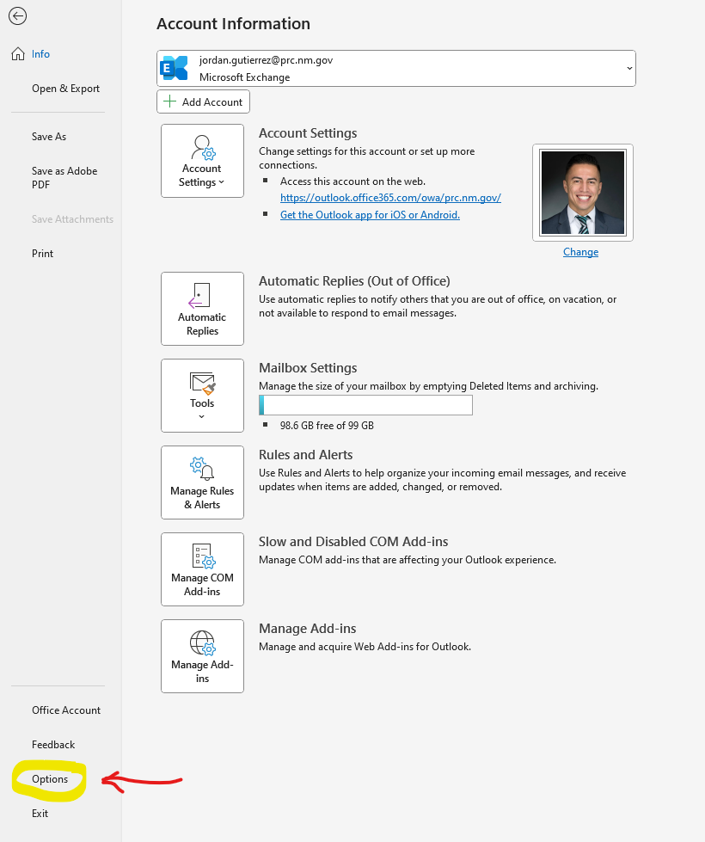**Step 2:** Once in the File folder, click on the “***Options***” tab in the bottom left corner.

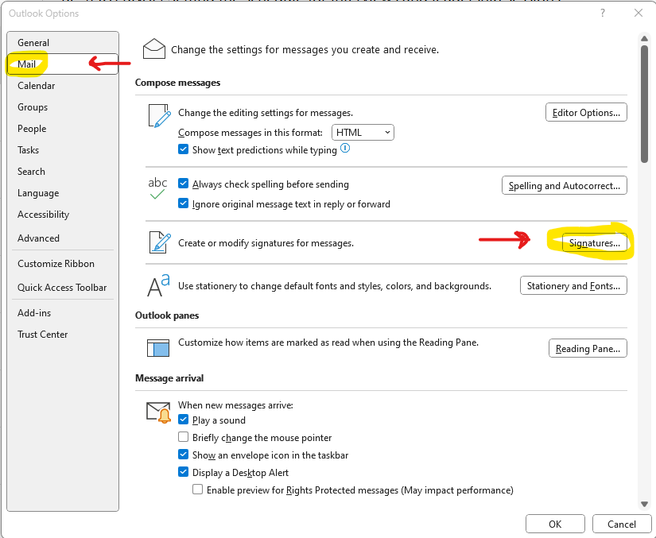**Step 3**: Once in the Options tab, click on the “***Mail***” tab on the left, and then click on the “***Signatures***..” button.

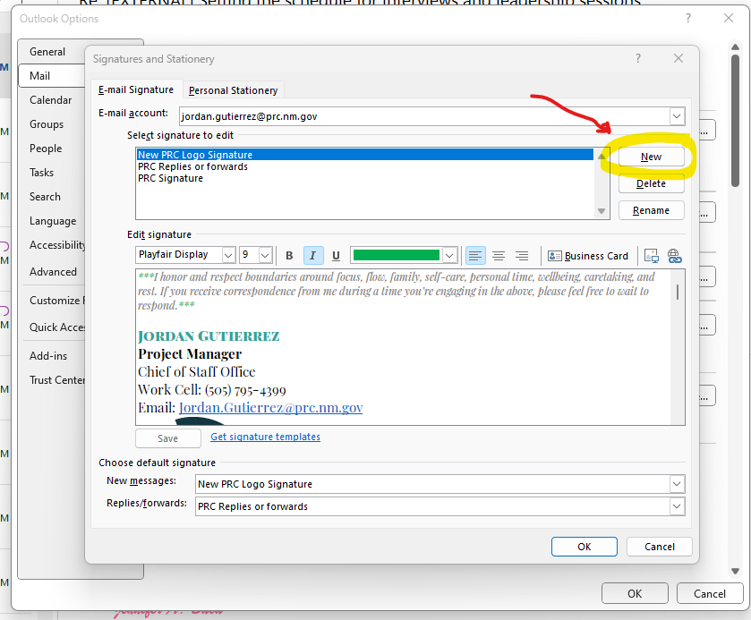**Step 4**: Once in the Signatures and Stationery window, click on the “***New***” button on the right.

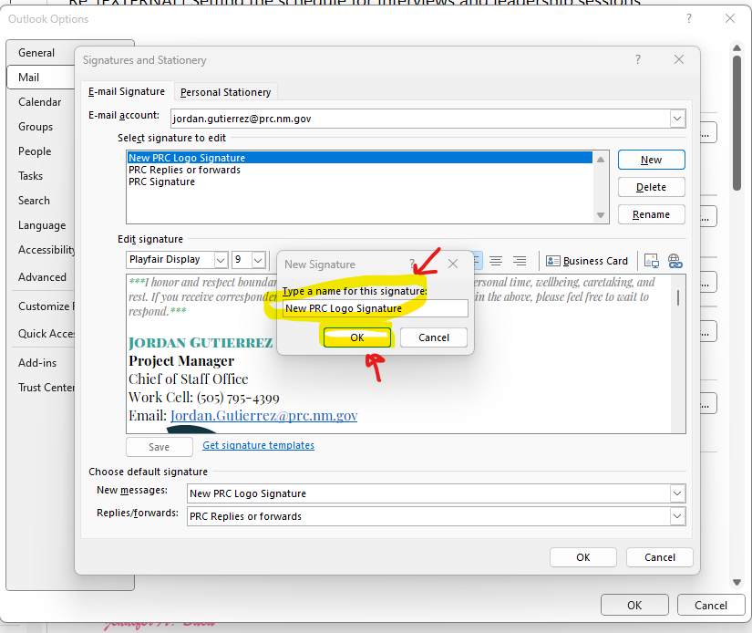**Step 5**: Once you click on the “***New***” button, type a name for your signature. (It can be anything you want it to be) then press “***Ok***”.

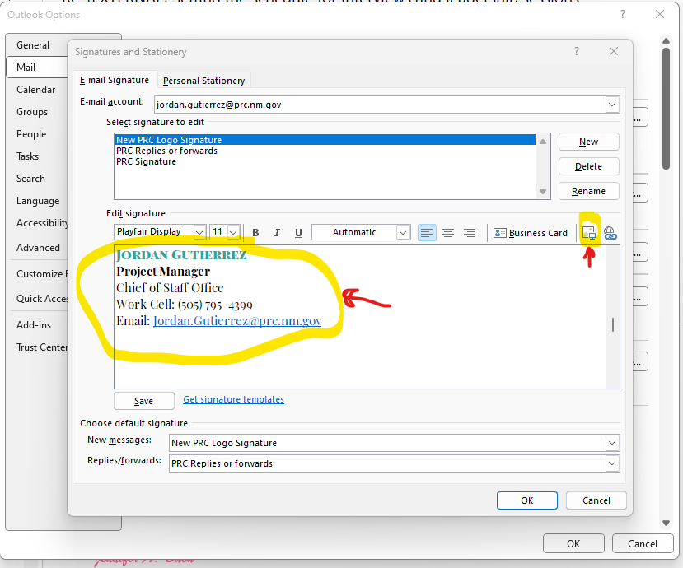**Step 6**: Type your contact information and press enter so the typing cursor is below your last sentence. Click on the “***Add Picture***” icon. *Advanced tips:* New Logo font: ***Playfair Display*** Logo Color: ***#29A39B***

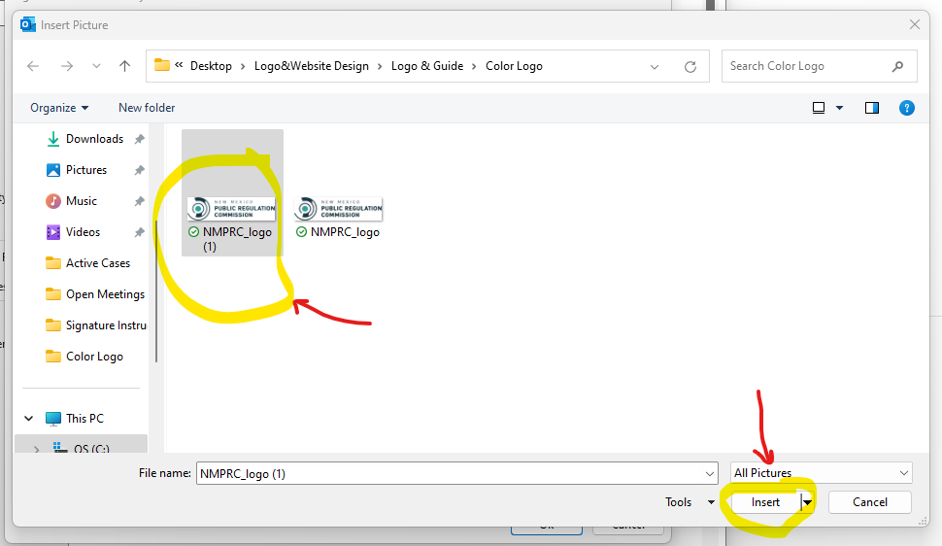**Step 7**: Find the logo you wish to add, ***single click on the logo*** and click “***Insert***”.

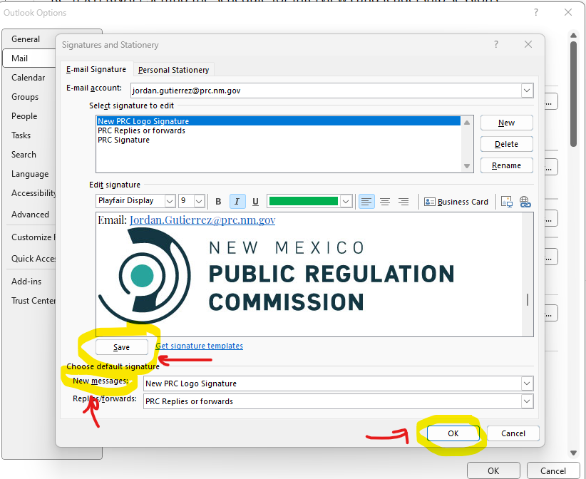**Step 8**: Once logo has been added, verify contact information, update font if you would like and click on the “***Save***” button. To add this signature to new messages make sure to select your new PRC signature in the “***New Messages***” scroll down bar. If you wish to include this signature in Replies and forwards, you can also select this signature in the “***Replies/forwards***” scroll down bar. Once finished, click “***Ok***”. Click “***Ok***” once more in the next screen.

**Congratulations!** Your new signature will now be included in your emails.

