How to Add Virtual Background to Zoom
Step 1: Save virtual backgrounds (from email) to your computer. (You will need this for step 4)
Step 2: Before/during your Zoom meeting, click on the arrow next to the Start/End Video button.


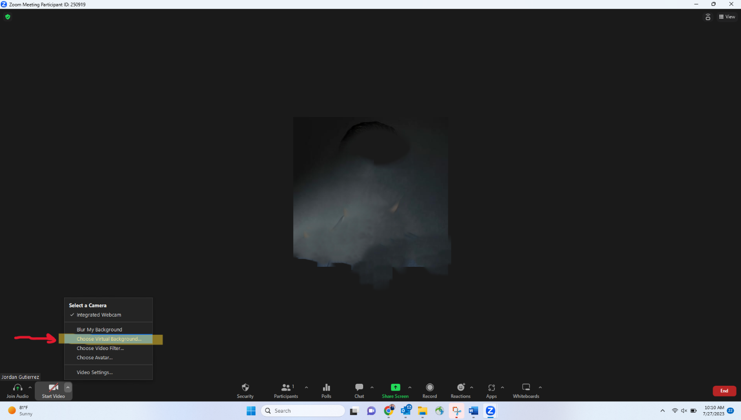
Step 3: Click on “Choose Virtual Background”

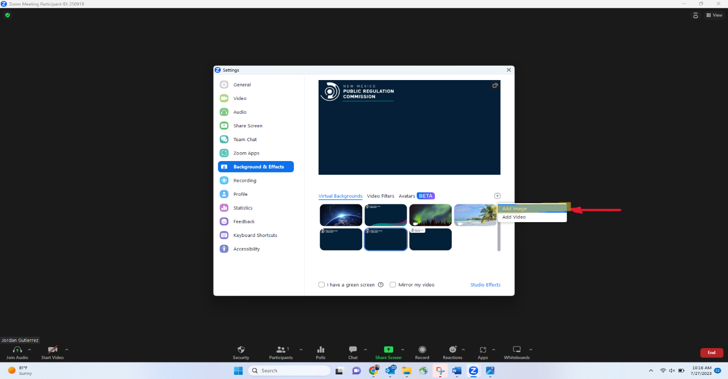
Step 4: Click on the + button as shown below and select saved virtual background picture (step 1).

Step 5: Once you select picture, it will be added with the other default virtual backgrounds. Click on your virtual background and exit the current page.
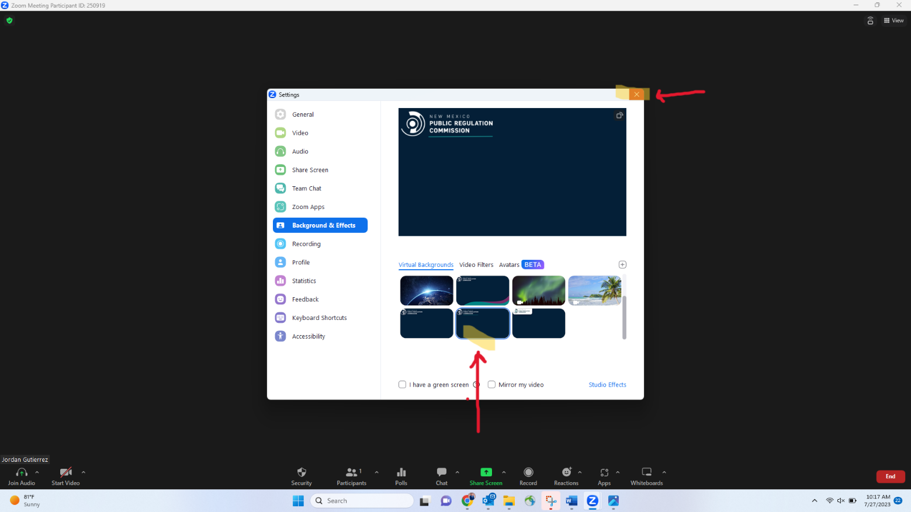

Step 6: Congratulations, you should now have PRC’s virtual background. Make sure your camera is on, smile, and have a wonderful meeting!


